UX-feedback report

Sam Philipsen

Inhoud

Introduction 3

Feedback session strategy 4

Pre-feedback screenshots 5

Feedback report 6

Post-feedback screenshots 7

# Introduction

Without gathering feedback about the user experience of my website, how will I know that it looks good? This is why getting user feedback is very important. Based on the feedback these test users give, I can improve the website’s user feedback. It is important to get people from different age groups so that the website can be as user friendly as it can be to every possible group of users.

# Feedback session strategy

My strategy for gathering user feedback in these sessions was very simple. I set them in front of the login screen and told them to use the website. I would not give them any instructions.

This worked for the most part with the younger test person, as he very quickly found out how to use the website. The older test person had a bit more difficulty with navigating the website as he could not see most of the smaller texts that came with losing or winning a game.

# Pre-feedback screenshots

Login page:

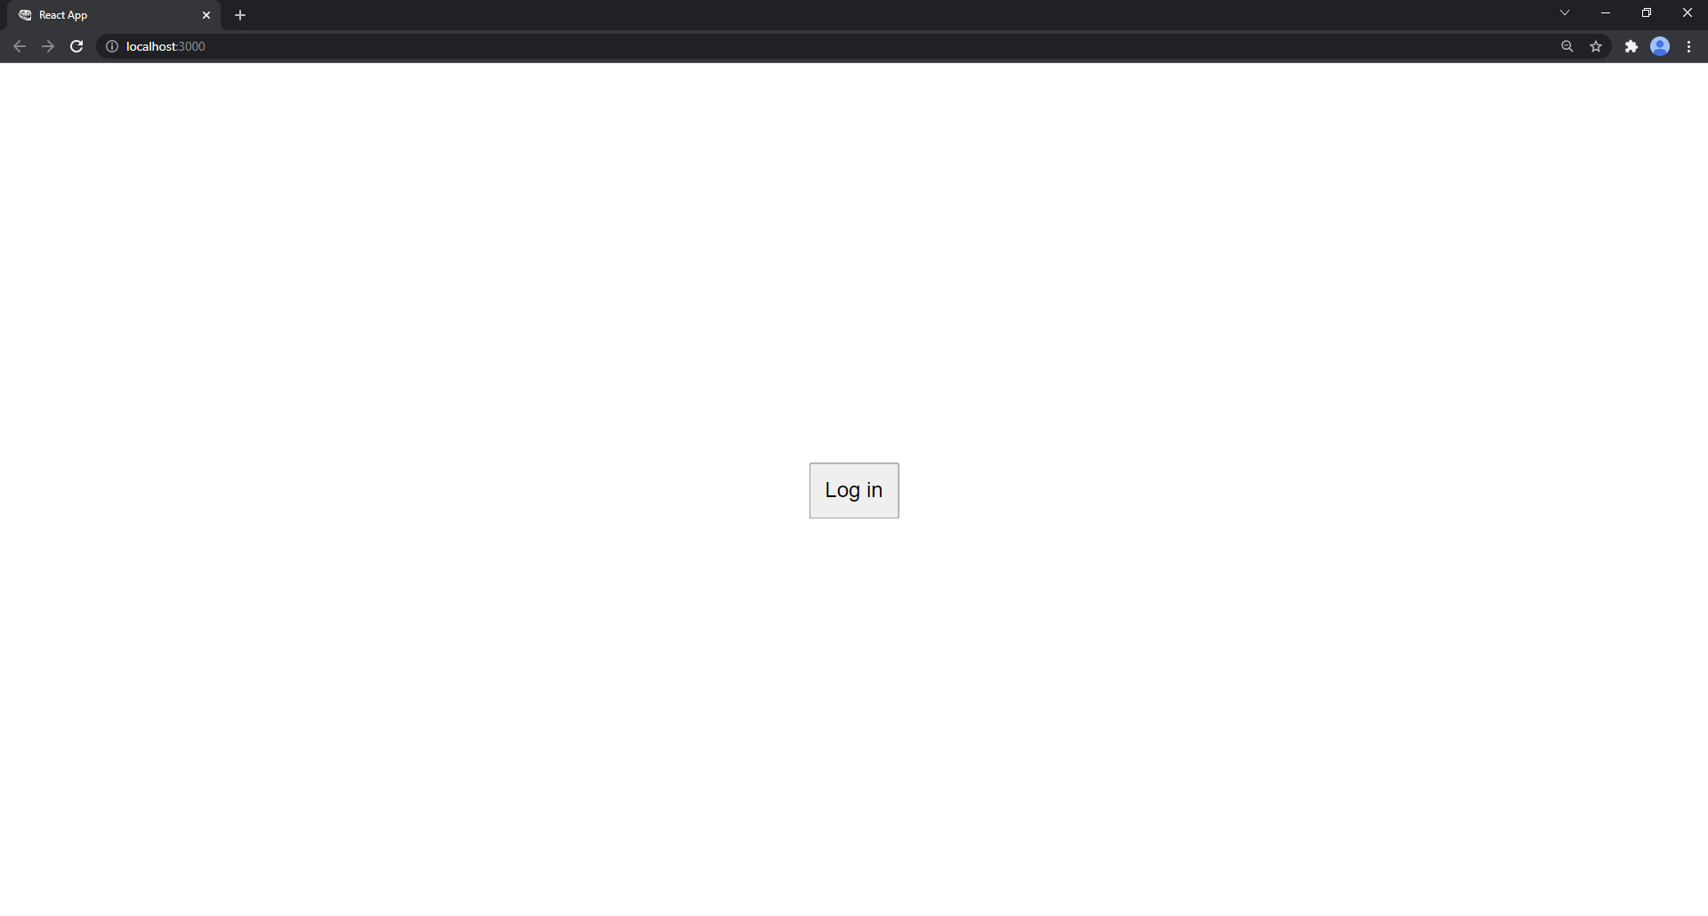

Main page:

# Feedback report

|  |  |  |
| --- | --- | --- |
| Name | Age | Feedback |
| Ivar Faessen | 19 | The design is clear, but it could use more styling like colors. It looks very bland. |
| Alex Philipsen | 54 | The messages when you do not have enough points to bet, or when you lose or win are not noticeable enough. They are very small. Maybe they can pop out, be bigger or have a different color. |

# Post-feedback screenshots

Login:

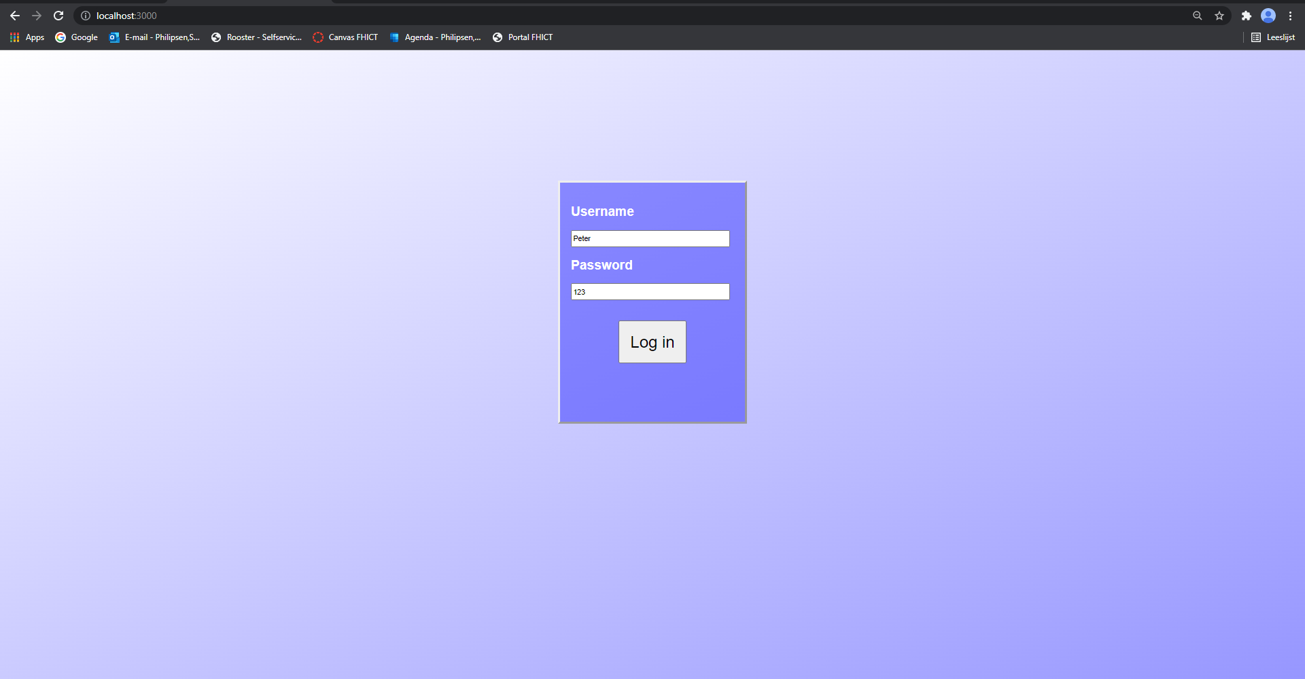

Main page:

